Name: _______________________ /46

**2015 Year 7 Biology Topic Test**

**Multiple Choice**

Please circle the correct answer on table below

|  |  |  |  |  |
| --- | --- | --- | --- | --- |
|  |  |  |  |  |
| **1.** | **A** | **B** | **C** | **D** |
| **2.** | **A** | **B** | **C** | **D** |
| **3.** | **A** | **B** | **C** | **D** |
| **4.** | **A** | **B** | **C** | **D** |
| **5.** | **A** | **B** | **C** | **D** |
| **6.** | **A** | **B** | **C** | **D** |
| **7.** | **A** | **B** | **C** | **D** |
| **8.** | **A** | **B** | **C** | **D** |
| **9.** | **A** | **B** | **C** | **D** |
| **10.** | **A** | **B** | **C** | **D** |
| **11.** | **A** | **B** | **C** | **D** |
| **12.** | **A** | **B** | **C** | **D** |
| **13.** | **A** | **B** | **C** | **D** |
| **14.** | **A** | **B** | **C** | **D** |
| **15.** | **A** | **B** | **C** | **D** |
| **16.** | **A** | **B** | **C** | **D** |
|  |  |  |  |  |

|  |  |  |  |  |
| --- | --- | --- | --- | --- |
|  |  |  |  |  |

1. Describe a decomposer organism.

A An animal that eats another animal

B A plant that loses its leaves in winter

C An organism that lives on Dead and decaying matter.

D An animal that uses sound as its main method of communication

2. Identify the **biotic** factor in an animals environment that can affect its survival.

A The amount of water available

B The quality of the air

C Events such as fire and flood

D Competition from other animals for food.

3. Why do scientists use scientific names to name living organism?

A To make communication of scientific information with other scientists easier.

B To avoid confusion about which living organism is being studied.

C Because Latin is an easy language to learn.

D Both answers A and B.

4. Which of the following organisms are in the same species?

*Canis familiaris*

*Canis aureus*

Vulpes vulpes

Sciurus vulgaris

A *Canis familiaris and Canis aureus*

B *Canis aureus and* Vulpes vulpes

C Vulpes vulpes and Sciurus vulgaris

D None are in the same species.

5. Which of the following will have the greatest number of different living organisms in it?

A Phylum.

B Kingdom.

C Order

D Genus

6. What is the ultimate source of energy for all the organisms in a food web.

A Soil.

B Water.

C Green plants.

D The Sun.

7. Define an organism’s habitat.

A The place where the organism lives

B The place where the organism is at a point in time

C The place where all the abiotic factors are suited to the organism’s survival

D A place where the organism hunts for food

8. **Define** adaptations.

A Living factors that influence where an organism lives

B Non-living factors that influence where an organism lives

C Features of an organism that help it survive in its environment

D Organisms that inhabit a specific region

9. **Identify** the term that is defined by the following: ‘an interaction between organisms in which both the organisms benefit from the relationship and neither is harmed’.

A Parasitism

B Commensalism

C Mutualism

D Competition

10. **Identify** the term that is defined by the following: ‘an interaction between two organisms in which one of them benefits but the other one is not affected’.

A Competition

B Parasitism

C Mutualism

D Commensalism

11. A fox is the ______________ which eats a rabbit. The rabbit is the ___________.

The two words needed to complete these sentences are:

A Carnivore and Prey

B Herbivore and Prey

C Commensalism and parasite

D Mutualism and host

12. A tape worm lives in the gut of humans. It takes nutrients from the humans and can be harmful. This is an example of.

A Predator/prey

B Commensalism

C Mutualism

D Parasite/host

13. **Interpret** the food web then identify the organisms that are **third-order** consumers.

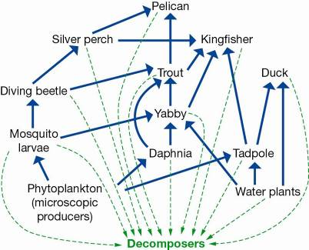

A Silver perch, trout, pelican

B Kingfisher, daphnia, trout

C Silver perch, tadpole, duck

D Pelican, duck, daphnia

14. **Identify** the food chain that is part of this food web.



A Phytoplankton -> daphnia -> trout -> duck -> decomposers

B Water plant -> tadpole -> trout -> kingfisher -> decomposers

C Phytoplankton -> mosquito larvae -> yabby -> silver perch -> pelican -> decomposers

D Water plant -> yabby -> trout -> kingfisher -> decomposers

15. Porifera, Arthropods, Molluscs and Cnidarians are all:

A Phylum’s of the animal kingdom.

B Classes of the animal kingdom.

C Phylum’s of the monera kingdom.

D Orders of the monera kingdom.

16. Living things are divided into:

A 2 kingdoms(plants and animals).

B 5 kingdoms.

C 20 kingdoms.

D 3 kingdoms(fungi, plants and animals).

**Short Answer Section**

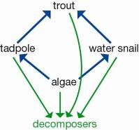

Please write your answers in the spaces provided

1. The diagram represents a food web in a freshwater lake.

What would happen tothe population of water snails if the trout fish were removed from the lake by too much fishing?

________________________________________________________________________________________________________________________________________________________________ (1 mark)

2. **State** whether each of the statements listed are **true or false**. Write T or F in the box.

a) The wind is a part of an organism’s environment.

b) Parasitism is an interaction in which one type of organism lives on or in another type of organism and usually causes it harm.

c) The forest that includes a tree in which a spider lives is regarded as the spider’s habitat.

d) Classification is putting things into groups according to similarities and dissimilarities.

e) Animals are all producers.

(5 marks)

3. Use your knowledge and the food chain below to answer the following questions.

Grass -> grasshopper -> frog -> snake -> kookaburra

____ _____ ____ ____ _____

**Classify** the organisms in this food chain as producers and consumers by writing a **P or C** under each organism. (5 marks)

4. Study the diagram shown, which represents a food web in a freshwater creek.

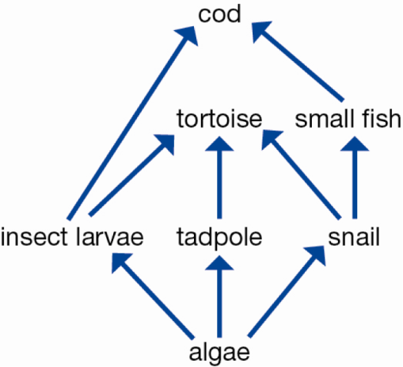

a) **Explain** what the arrow between two organisms means.

(1 mark)

b) **Draw** **TWO different food chains** that include the tortoise.

(2 marks)

5. Use this classification key to complete the table below it.

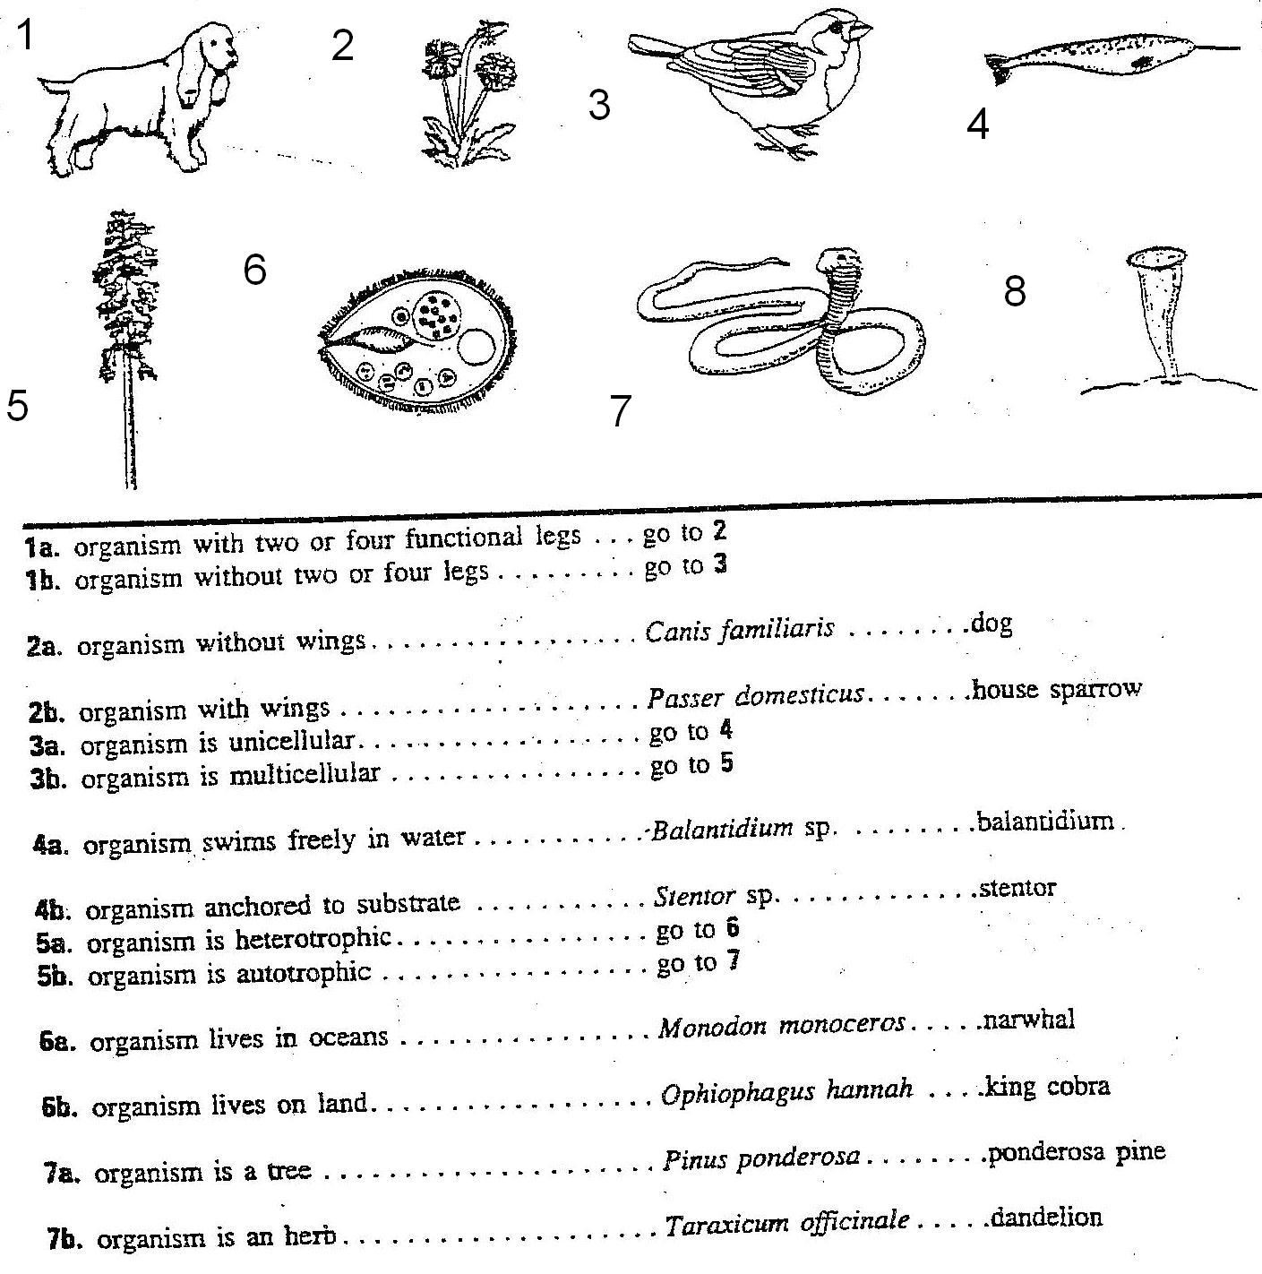

|  |  |
| --- | --- |
| Organism number | Scientific name of organism |
| 2 |  |
| 3 |  |
| 4 |  |
| 5 |  |
| 6 |  |
| 7 |  |
| 8 |  |

(7 marks)

6. These three images are of birds that eat very different food.

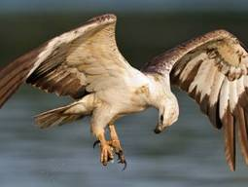

Eagles swoop down from a great height to catch live mice and other small animals for food.

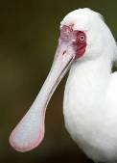

Spoonbills sift through the mud for small insects and crabs to eat.

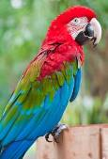

Parrots bite and tear at fruit. They also crack open seeds to get at the soft kernels inside.

From the information and photographs provided state the **adaptations** these three birds have that enable them to access the food they eat. (3 marks)

Eagle:_________________________________________________________________________________________________________________________________________________________________________________________________________________________________________________

Spoonbill:______________________________________________________________________________________________________________________________________________________________________________________________________________________________________________

Parrot:_________________________________________________________________________________________________________________________________________________________________________________________________________________________________________________

7. The arachnids, insects and crustaceans are all in which phylum?

____________________________________________________

(1 mark)

8. Look at the diagram below. Use it to draw a bar graph showing the relative percentage of described species of invertebrates, plants and vertebrates. Use the graph paper on the next page.

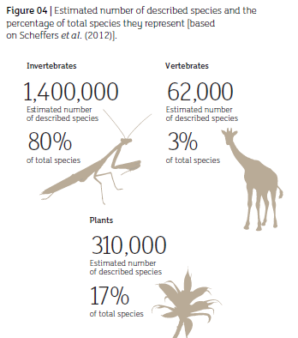

(5 marks)

